**TOOLS FOR MASONRY**

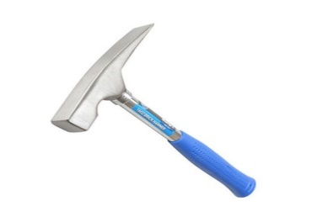**BRICK HAMMER**

A Stonemason's hammer, also known as a Brick Hammer, has one flat traditional face and a short or long chisel-shaped blade. It can thus be used to chip off edges or small pieces of stone, cut brick or a concrete masonry unit, without using a separate chisel.

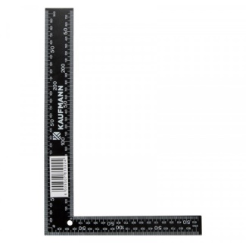**BUILDERS SQUARE**

The Builders Square is used where walls meet, calculating rafter angles, creating stairways, calculating octagons, and can be used as a diagonal square

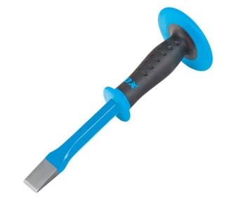**CHISEL**

A chisel is a tool with a characteristically shaped cutting edge of blade on its end, for carving or cutting a hard material such as wood, stone, or metal by hand, struck with a mallet, or mechanical power. The handle and blade of some types of chisel are made of metal or of wood with a sharp edge in it.

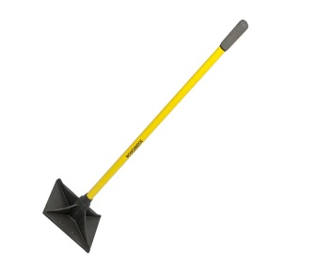**HAND RAMMER**

Hand rammer, Molder tool for ramming up and compacting mold material in a purely manual fashion (see Ramming). Depending on the shape of the ramming tip, hand rammers are available as pegging rammers and bench rammers made of wood or metal or with solid-rubber ramming heads.

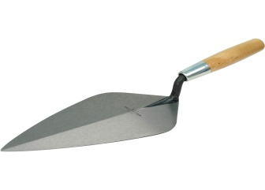**HAND TROWEL**

A trowel is a small hand tool used for digging, applying, smoothing, or moving small amounts of viscous or particulate material.

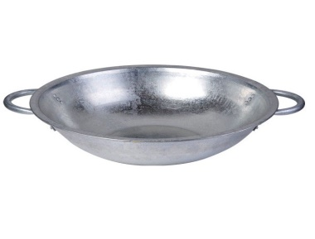**HEAD PAN**

A round container , like a bowl , used in construction work.

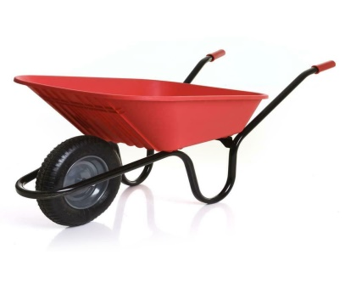**WHEELBARROW**

A wheelbarrow is a small hand-propelled vehicle, usually with just one wheel, designed to be pushed and guided by a single person using two handles at the rear, or by a sail to push the ancient wheelbarrow by wind. ... The use of one wheel also permits greater control of the deposition of the load upon emptying.

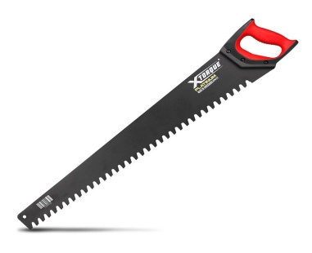**MASON HAND SAW**

This is a masonry handsaw designed for both softer and medium hard materials. So it will cut plaster blocks, lightweight blocks and autoclaved aerated concrete blocks (AAC blocks), but also clay bricks and hollow blocks such as Poroton or Poroterm.

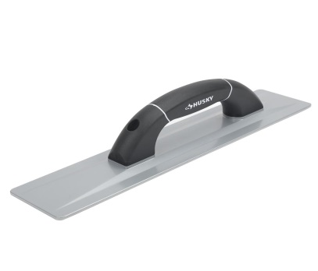**METAL FLOAT**

Normally materials that are denser than water (they have more mass per unit volume), such as metals, will sink. Metal boats, however, can float because their hulls are shaped so they displace a lot of water (that is, there is a lot of empty air space inside the boat).

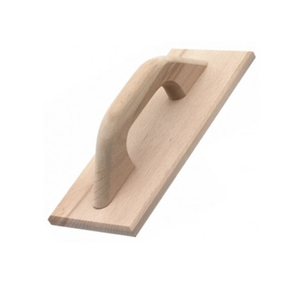**WOODEN FLOAT**

A Wooden Float is a tool with a smooth plane that is applied on freshly laid mortar and concrete during surface finishing. To use a Wooden Float, hold the handle firmly with one hand and position the plain against the surface without any tilt such that it makes full contact.

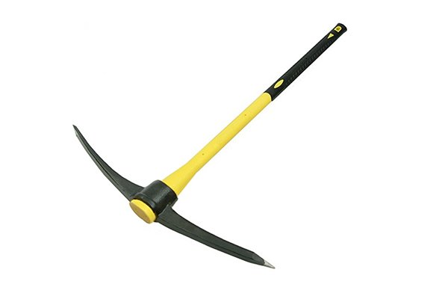**PICK AXE**

A pickaxe, pick-axe, or pick is a generally T-shaped hand tool used for prying. Its head is typically metal, attached perpendicularly to a longer handle, traditionally made of wood, occasionally metal, and increasingly fiberglass.

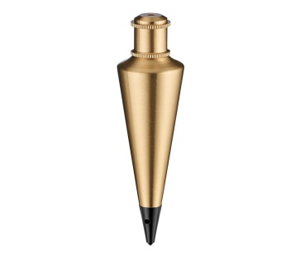**PLUMB BOB**

A plumb bob, or plummet, is a weight, usually with a pointed tip on the bottom, suspended from a string and used as a vertical reference line, or plumb-line. It is a precursor to the spirit level and used to establish a vertical or horizontal datum.

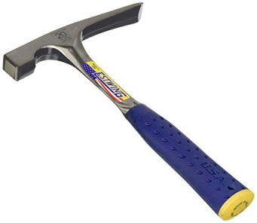**SKUTCH HAMMER**

Scutch hammers, in conjunction with combs and droves, are used for cutting bricks in the same way as scutch chisels, however, they are not as precise in their work, due to lack of control when wielding a hammer in comparison to a chisel.

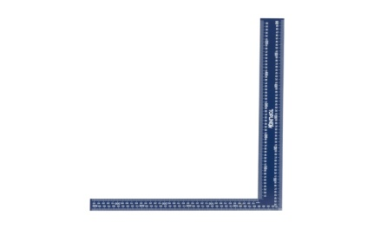**BUILDERS SQUARE**

The Builders Square is used where walls meet, calculating rafter angles, creating stairways, calculating octagons, and can be used as a diagonal square.

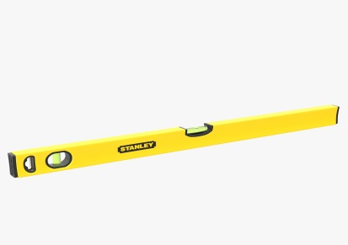**SPIRIT LEVEL**

A spirit level, bubble level or simply a level is an instrument designed to indicate whether a surface is horizontal or vertical.

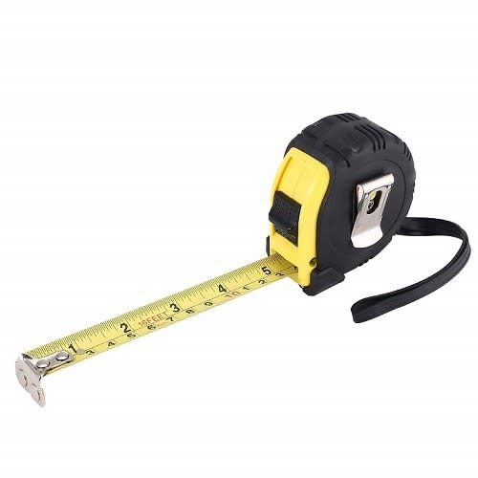**TAPE MEASURE**

A tape measure or measuring tape is a flexible ruler used to measure distance. It consists of a ribbon of cloth, plastic, fibre glass, or metal strip with linear-measurement markings. It is a common measuring tool.

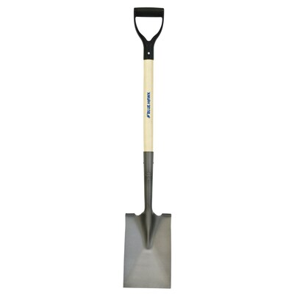**SPADE**

A spade is a tool primarily for digging, comprising a blade – typically stunted and less curved than that of a shovel – and a long handle.

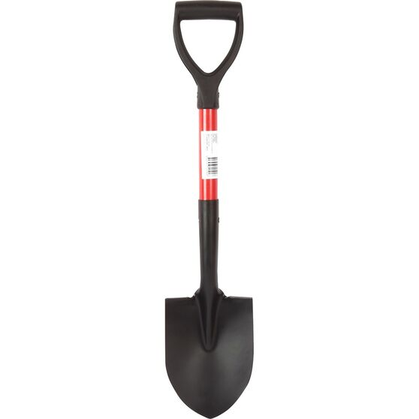**SHOVEL**

A shovel is a tool for digging, lifting, and moving bulk materials, such as soil, coal, gravel, snow, sand, or ore. Most shovels are hand tools consisting of a broad blade fixed to a medium-length handle. Shovel blades are usually made of sheet steel or hard plastics and are very strong.

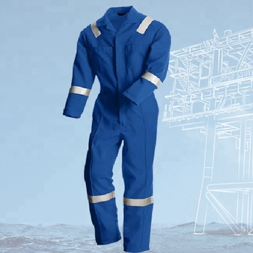**COVERALL**

A one-piece protective garment worn for heavy manual work; a boiler suit.

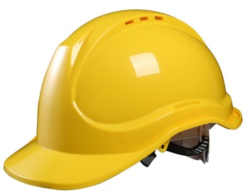**HELMENT**

A hardhat is a type of helmet predominantly used in workplace environments such as industrial or construction sites to protect the head from injury due to falling objects, impact with other objects, debris, rain, and electric shock. ... Some helmet shells have a mid-line reinforcement ridge to improve impact resistance.

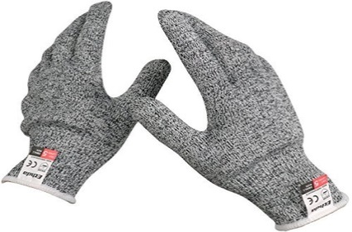**HANDGLOVE**

A glove is a garment covering the whole hand. Gloves usually have separate sheaths or openings for each finger and the thumb. If there is an opening but no (or a short) covering sheath for each finger they are called fingerless gloves.

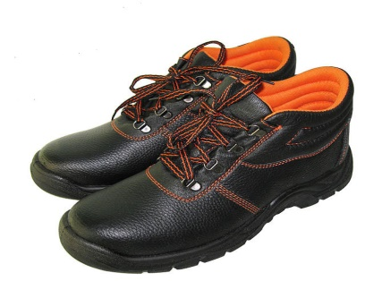**SAFETY WORK SHEOS (LEATHER)**

Safety boots are shoes made with a protective reinforcement at the front making them quite durable. The reinforcement helps to protect the toes from falling objects or any kind of compression. They are normally installed with a sole plate in the main sole to prevent against punctures that may come from below.